AUM hOMe Shala Yoga
Adolescent In-Take Form
Confidential Health Background

Personal Information

Student Name: ___________________________________ Birthday: ____________

Sex: ______ Height: ________ Weight: _______

Parent Name: _______________________________________________

Parent Address: ________________________City: __________ State: _____ Zip:___________

Daytime Phone: (_____) _________________ Evening Phone: (_____) _________________

Parent Email Address: ______________________________________________

School Student Presently Attends: _______________________________ Grade: _________

School(s) Student has Previously Attended (include Grades completed and years spent at each school):__________________________________________

School Programs (Gifted, Special Needs, etc)________________________________________

Extracurricular Activities: ________________________________________________________

Emergency Contact: ____________________________ Phone: (_____) __________________

How did you hear about us? Referred by?

The following confidential information will be used to plan safe and effective yoga therapy sessions. Please answer the questions to the best of your knowledge.

Reason for your visit

What is your primary issue? _____________________________________________________

How often do you experience your symptoms? (circle one)
Constantly (76-100% of the time) Frequently (50-75%) Occasionally (26-50%) Intermittently (up to 25%)

When did you first notice it? _______________ Do you know what brought it on? _________

What activities provide relief? ____________________________________________________

What makes it worse? __________________________________________________________

How are your symptoms changing with time? (circle one)
Getting Worse Staying the same Getting better

Have you tried any other therapies or treatments? (Y/N) If yes, please describe:

Describe your sleep (times for sleep, deep sleep, restless sleep, how many hours/day):

What do you hope to accomplish? ________________________________________________________________________

___ Body Awareness
___ Muscle Strengthening ___ Muscle Stretching and Flexibility
___ Improve Other Body Systems: ___ Stabilization of Joints
___ Diet and Lifestyle ___ Pain Reduction
___ Digestion and Elimination ___ Overall Posture Improvement
___ Specific Yoga Postures or Practices ___ Improve Breathing
___ Improve Energy Level ___ Improve Sleep
___ Breath Awareness ___ Overall Stress Reduction
___ Less Trouble Handling Emotions ___ Less Reactive/Upsetting
___ Less Anxiety or Depression ___ More Satisfying Personal Relationships
___ Finding Greater Fulfillment at Work ___ Greater Sense of Self-esteem
___ Other goals:_______________________________________________________________
How much time per day can you devote to doing yoga or healing work?
_______________________________________
Health History

Are you currently under a physician’s care for an acute or chronic issue? (Y/N)
If yes, please explain __________________________________________________________

Health Care Provider: ______________________Date of last Physical Exam: _________

What do you do for relaxation/exercise?
_______________________________________________________________________

Do you exercise regularly and/or participate in any sport? (Y/N)

If yes, which sport? _______________________________________________

Have you recently suffered an injury? (Y/N)
If yes, please explain

_____________________________________________________________

Are you uncomfortable with any of the following areas:
Gluteal Region (Y/N) Pectoral Region (Y/N) Face/Scalp (Y/N) Feet (Y/N)

Please list any medications (vitamins, herbs or pharmaceutical) you are currently taking or at regular intervals? ________________________________________________________________________

________________________________________________________________________

Please list any injuries/accidents/illnesses or surgeries still affecting you and how you have been caring for them: ________________________________________________________________________

________________________________________________________________________

Do you experience stress in your school, work, family or other aspects of your life?
(Circle the one that best describes)

And how you believe it affects your health:
Muscle tension Anxiety Insomnia Irritability Digestive Disturbances

Other: _______________________________________
Circle the face or faces that best describes how you are feeling:
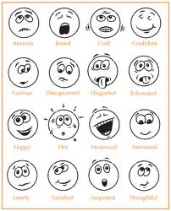

Using the symbols below, please identify the areas of concern on the chart below:

/// (sharp pain) xxx (burning , radiating pain) ~~~~ (numbness) 000 (dull ache)

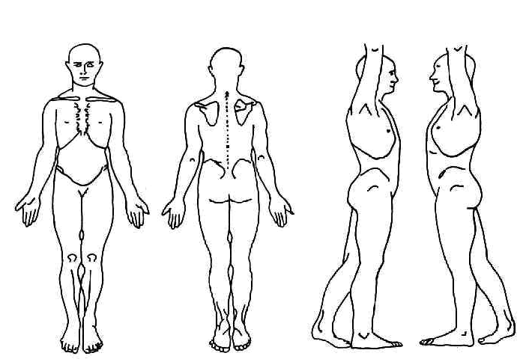

Health History
Please indicate any Present (P), Past (X), or Reoccurring (C) conditions:

____ ADD/ADHD ____Metal implants / artificial joints
____ Allergies ____ Mononucleosis
____ Alzheimer’s disease ____ Multiple Sclerosis
____ Anxiety disorder what stage? __________________
____ Arthritis ____ Muscular Dystrophy
____ Athletes foot ____ Numbness/ Tingling
____ Asthma ____ Osteoporosis/Osteopenia
____ Blood Clot/ Deep Vein Thrombosis/ ____Osteoarthritis
Phlebitis/ Embolism ____ Pain
____ Broken or fractured bones ____ Rheumatoid Arthritis ____ Bursitis Location: ____________________
____ Cancer Muscular or Joint: _____________
Location: ___________________ Chronic? Y/N
Treatment: __________________ ____ Paralysis
In Remission? Y/N ____ Parkinson’s disease
____ Carpal Tunnel Syndrome ____ Pregnancy
____ Cerebral Palsy ____ Psoriasis
____ Chronic Fatigue Syndrome ____ Rash
____ Contagious condition ____ Sciatica
____ Crohn’s disease ____ Scoliosis
____ Depression ____ Seizure
____ Diabetes ____ Sleeping problems
____ Type I ____ Type II ____ Spasms/ Cramping
____ Diverticulitis ____ Strain/ Sprain
____ Eczema ____ Stroke
____ Epilepsy ____ Tendonitis
____ Epstein Barr ____ Thyroid issues
____ Fertility Concerns ____ TMJ/ Jaw Pain
____ Fibromyalgia ____ Tumor
____ General Fatigue Location_________________
____ Gout Malignant or Benign? ___________
____ Headaches ____ Varicose Veins
Type: ________Frequency: ___________ ____ Vertigo, dizziness or loss of
____ Hearing Impairment balance
____ Heart Condition _____Menstruation
____ Herpes/ Shingles _____ PMS/Symptoms_______
____ High/ Low Blood Pressure ______________________________
____ High/ Low Cholesterol
____ HIV/AIDS Other_________________________
____ Lupus
____ Lymph edema ______________________________

AUM hOMe Shala Professional Disclosure Form and General Release
We are delighted to have you as a Yoga student. The following information will help you get the most out of your Yoga classes and clarify the role of a Yoga teacher. Please read and sign below.
- I am a Yoga Teacher at AUM hOMe Shala and have completed a thorough professional training in Yoga instruction. I have a Yoga Certification and am registered with the Yoga Alliance. Yoga is much more than physical exercise; it is a transformational practice that integrates body, mind and spirit. Yoga is a way of encountering and releasing physical, mental, and emotional tensions to arrive at deeper levels of relaxation and awareness.
- All exercise programs involve a risk of injury. By choosing to participate in my
Yoga classes, or any other classes at AUM hOMe Shala, you voluntarily assume a certain risk of injury. The following guidelines will help you reduce your risk of injury:
- Listen to and follow Yoga Teacher’s instructions carefully.
- Breathe smoothly and continuously as you move and stretch.
- Do not hold your breath or strain to attain any position.
- Work gently, respecting your body’s abilities and limits.
- Don’t perform postures or movements that are painful.
- Ask if you are unsure how to perform a certain movement.
- Menstruating women should not practice inverted postures.
- Pregnant women must consult their health care provider before enrolling in class.
3. It is always advisable to consult your physician before embarking on any exercise
program. Please complete the Student Health Questionnaire Form and inform the
teacher of any health conditions that could be affected by your practice of Yoga.
If you are unsure about a condition, please speak to your teacher.
- Awareness is fundamental to the practice of Yoga. It is your responsibility as a
student to monitor each activity and determine whether it is appropriate for you to
participate. Though I am your teacher, you remain primarily responsible for your
safety and well-being.
The undersigned assumes all risk of damage or injury that may occur as a student in AUM Home Shala Yoga classes, both while attending classes and following instruction at home. In consideration of being accepted as a Yoga student the undersigned releases and discharges Melinda Atkins and AUM hOMe Shala and teachers from any and all claims, demands, actions of any nature, whether present or future, anticipated or unanticipated, known or unknown, that result from the undersigned’s participation in Yoga classes or practice of Yoga outside of class.
I have read, understand, and agree to the content of the Professional Disclosure Form and General Release.
____________________________________________ __________________________
Signature (Parent or Guardian) Date

Print Name Teacher’s Name

Release and Consent to Photograph
For use to create AUM Home Shala Yoga Protocols for Student Use

Student’s Name:________________________________________________________________
(PLEASE PRINT)

Parent’s Name:________________________________________________________________
(PLEASE PRINT)

Address: ________________________________________________________________________

________________________________________________________________________

Phone Numbers: (H) ________________________ (Cell)___________________________

AUM Home Shala established its Yoga Teachers Training Program in 2005. I understand that AUM hOMe routinely promotes the educational and health benefits of participating in the activities of on going Yoga classes and training programs.

I hereby consent to my child being the subject of photographs taken to create AUM Home Shala Yoga protocols for educational use by the student and hereby release AUM hOMe from any and all claims for damages for libel, slander, invasion of privacy or any other claim based upon the use of my image and likeness as stated above.

__________________________________________________ __________________________
Parent Signature (if student is under 18) Date

___________________________________________________ __________________________
Melinda Atkins, M.ED., E-RYT500C Date
Director

