AUM Home Shala Yoga Therapy
Dear Yoga Therapy Case Study Applicant,

Many thanks for your interest in our program. We will do our best to secure a spot for you in our on-going free Saturday Clinic. Our only request is your commitment to at least six (6) sessions so that our Clinical Therapy candidates may monitor and learn from your progress. Each session will provide you with a comprehensive Yoga Therapy Protocol along with picture tutorial taken during your session so that you might practice at home.

To apply, please fill out the attached Clinical Case Study Application, read and sign the attached Disclosure and Photo Release forms, and return to my attention at:

AUM Home Shala
Attn: Melinda Atkins, Director 3104 Florida Ave.
Coconut Grove, FL 33133

Should you have any questions, feel free to contact us via email (info@aumhomeshala.org) or phone (305-441-9441) .

Namaste,
Melinda Atkins Director

Clinical Case Study Application
Confidential Health Background

Personal Information
Name: ___________________________________ Birthday: _____________
Daytime Phone: (_____) _________________ Evening Phone: (_____) __________________
Email Address: ______________________________________________

Occupation: _________________________
Address: __________________________ City: _____________ State: _____ Zip: ___________
Emergency Contact: ____________________________ Phone: (_____) __________________

The following confidential information will be used to plan safe and effective yoga therapy sessions. Please answer the questions to the best of your knowledge.

Reason for your visit

What is your primary issue? _____________________________________________________
How often do you experience your symptoms?
Constantly (76-100% of the time) Frequently (50-75%) Occasionally (26-50%) Intermittently (up to 25%)
When did you first notice it? _______________ Do you know what brought it on? _________
What activities provide relief? ____________________________________________________
What makes it worse? __________________________________________________________
How are your symptoms changing with time? (circle one)
Getting Worse Staying the same Getting better
Have you tried ay other therapies or treatments? (Y/N)
If yes, please describe: ______________________________________________________
Describe your sleep recently: ____________________________________________________________________________

What do you hope to accomplish? ________________________________________________
_____________________________________________________________________________
___ Body Awareness
___ Muscle Strengthening ___ Muscle Stretching and Flexibility
___ Improve Other Body Systems: ___ Stabilization of Joints
___ Diet and Lifestyle ___ Pain Reduction
___ Digestion and Elimination ___ Overall Posture Improvement
___ Specific Yoga Postures or Practices ___ Improve Breathing
___ Improve Energy Level ___ Improve Sleep
___ Breath Awareness ___ Overall Stress Reduction
___ Less Trouble Handling Emotions ___ Less Reactive/Upsetting
___ Less Anxiety or Depression ___ More Satisfying Personal Relationships
___ Finding Greater Fulfillment at Work ___ Greater Sense of Self-esteem
___ Other goals:_______________________________________________________________

How much time per day can you devote to doing yoga or healing work? ________________________________________

Health History

Are you currently under a physician’s care for an acute or chronic issue? (Y/N)
If yes, please explain __________________________________________________________
Health Care Provider: _____________________Date of last Physical Exam: _________

What do you do for relaxation/exercise? ___________________________________________
_____________________________________________________________________________
Do you exercise regularly and/or participate in any sport? (Y/N)
If yes, which sport? _______________________________________________
Have you recently suffered an injury? (Y/N)
If yes, please explain _____________________________________________________________

Are you uncomfortable with any of the following areas:
Gluteal Region (Y/N) Pectoral Region (Y/N) Face/Scalp (Y/N) Feet (Y/N)

Please list any medications (vitamins, herbs or pharmaceutical) you are currently taking or at regular intervals? __________________________________________________________________________________________________________________________________________________________

Please list any injuries/accidents/illnesses or surgeries still affecting you and how you have been caring for them: __________________________________________________________________________________________________________________________________________________________

Do you experience stress in your work, family or other aspects of your life?
(Circle the one that best describes)

And how you believe it affects your health:
Muscle tension Anxiety Insomnia Irritability Digestive Disturbances
Other: _______________________________________

Circle the face or faces that best describes how you are feeling

Using the symbols below, please identify the areas of concern on the chart below:

/// (sharp pain) xxx (burning , radiating pain) ~~~~ (numbness) 000 (dull ache)

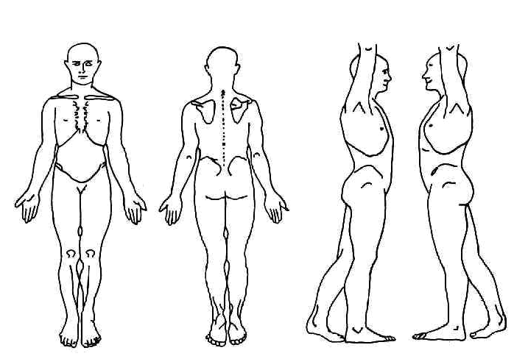

Health History
Please indicate any Present (P), Past (X), or Reoccurring (C) conditions:

____ ADD/ADHD ____Metal implants / artificial joints
____ Allergies ____ Mononucleosis
____ Alzheimer’s disease ____ Multiple Sclerosis
____ Anxiety disorder what stage? __________________
____ Arthritis ____ Muscular Dystrophy
____ Athletes foot ____ Numbness/ Tingling
____ Asthma ____ Osteoporosis/Osteopenia
____ Blood Clot/ Deep Vein Thrombosis/ ____Osteoarthritis
Phlebitis/ Embolism ____ Pain
____ Broken or fractured bones ____ Rheumatoid Arthritis ____ Bursitis -Location: ____________________
____ Cancer --Muscular or Joint: _____________
--Location: ___________________ -- Chronic? Y/N
--Treatment: __________________ ____ Paralysis
-- In Remission? Y/N ____ Parkinson’s disease
____ Carpal Tunnel Syndrome ____ Pregnancy
____ Cerebral Palsy ____ Psoriasis
____ Chronic Fatigue Syndrome ____ Rash
____ Contagious condition ____ Sciatica
____ Crohn’s disease ____ Scoliosis
____ Depression ____ Seizure
____ Diabetes ____ Sleeping problems
____ Type I ____ Type II ____ Spasms/ Cramping
____ Diverticulitis ____ Strain/ Sprain
____ Eczema ____ Stroke
____ Epilepsy ____ Tendonitis
____ Epstein Barr ____ Thyroid issues
____ Fertility Concerns ____ TMJ/ Jaw Pain
____ Fibromyalgia ____ Tumor
____ General Fatigue --Location: ____________________
____ Gout --Malignant or Benign? ___________
____ Headaches ____ Varicose Veins
--Type: __________ Frequency: ___________ ____ Vertigo, dizziness or loss of balance
____ Hearing Impairment ____Other: _____________________
____ Heart Condition
____ Herpes/ Shingles
____ High/ Low Blood Pressure
____ High/ Low Cholesterol
____ HIV/AIDS
____ Lupus
____ Lymph edema

Disclosure Statement

In consideration of AUM Home Shala, Inc. and/or Melinda Atkins extending to me the privilege of participating in their Yoga & Therapies program, I fully assume all risks and waive all liability in connection with my participation in any program, and in particular, without limitation, to the extent permitted by law, I and my heirs, representatives, executors, or administrators and my undersigned parent, guardian or aide (if applicable) remise, release, indemnify, acquit and hold harmless and forever discharge AUM Home Shala, Inc. and/or Melinda Atkins , their directors, employees, and agents, instructors, including volunteers, rescue and support personnel, from any and all liabilities, obligations, damages, claims, causes of action, judgments, costs and charges which I may have or which may be incurred by me for any reason of any occurrence during my travel to and from the event, or during my participation therein, whether resulting from any acts or omissions of any persons, from the operation or condition of facilities or premises, or from acts of God or nature. I hereby agree to comply with all rules and regulations, give my permission for the free use of my name and picture in any media account of the AUM Home Shala, Inc. and/or Melinda Atkins, Yoga & Therapies programs or any future public relations or fundraising activity. I also agree to assume liability for all and any damages to AUM Home Shala, Inc. and/or Melinda Atkins, property that is under my control while participating in any AUM Home Shala, Inc. and/or Melinda Atkins, Inc activity. Not all techniques are suitable for everyone. Participation in any treatment/exercise program may result in injury. By doing the movements, exercises, you assume the risk of injury from performing the movements and techniques shown. Consult your physician before doing any exercises, especially if you suffer from an injury or medical condition.
______________________________________ ______________________________
Student’s Name (please print) Student Contact #

________________________________ _______________________________
Student’s Name (please sign) Emergency Contact Name & Phone #

_______________________________ ________________________________
Date E-mail address

Mailing Address: _________________________________

_________________________________

_________________________________

