Clinical Group Case Study Application
Confidential Health Background
AUM Home Shala Yoga Therapy
Bust the Winter Blues: Yoga Therapy to Ease Holiday Stress and Light Deprivation
Personal Information
Name: ___________________________________ Birthday: _____________
Daytime Phone: (_____) _________________ Evening Phone: (_____) __________________
Email Address: ______________________________________________

Occupation: _________________________
Address: __________________________ City: _____________ State: _____ Zip: ___________
Emergency Contact: ____________________________ Phone: (_____) __________________

The following confidential information will be used to plan safe and effective yoga therapy sessions. Please answer the questions to the best of your knowledge.

Reason for your visit

What is your primary issue? _____________________________________________________
How often do you experience your symptoms?
Constantly (76-100% of the time) Frequently (50-75%) Occasionally (26-50%) Intermittently (up to 25%)
When did you first notice it? _______________ Do you know what brought it on? _________
What activities provide relief? ____________________________________________________
What makes it worse? __________________________________________________________
How are your symptoms changing with time? (circle one)
Getting Worse Staying the same Getting better
Have you tried ay other therapies or treatments? (Y/N)
If yes, please describe: ______________________________________________________
Describe your sleep recently: ____________________________________________________________________________

What do you hope to accomplish? ________________________________________________
_____________________________________________________________________________
___ Body Awareness
___ Muscle Strengthening ___ Muscle Stretching and Flexibility
___ Improve Other Body Systems: ___ Stabilization of Joints
___ Diet and Lifestyle ___ Pain Reduction
___ Digestion and Elimination ___ Overall Posture Improvement
___ Specific Yoga Postures or Practices ___ Improve Breathing
___ Improve Energy Level ___ Improve Sleep
___ Breath Awareness ___ Overall Stress Reduction
___ Less Trouble Handling Emotions ___ Less Reactive/Upsetting
___ Less Anxiety or Depression ___ More Satisfying Personal Relationships
___ Finding Greater Fulfillment at Work ___ Greater Sense of Self-esteem
___ Other goals:_______________________________________________________________
How much time per day can you devote to doing yoga or healing work? ________________________________________

Health History

Are you currently under a physician’s care for an acute or chronic issue? (Y/N)
If yes, please explain __________________________________________________________
Health Care Provider: _____________________Date of last Physical Exam: _________

What do you do for relaxation/exercise? ___________________________________________
_____________________________________________________________________________
Do you exercise regularly and/or participate in any sport? (Y/N)
If yes, which sport? _______________________________________________
Have you recently suffered an injury? (Y/N)
If yes, please explain _____________________________________________________________

Are you uncomfortable with any of the following areas:
Gluteal Region (Y/N) Pectoral Region (Y/N) Face/Scalp (Y/N) Feet (Y/N)

Please list any medications (vitamins, herbs or pharmaceutical) you are currently taking or at regular intervals? __________________________________________________________________________________________________________________________________________________________

Please list any injuries/accidents/illnesses or surgeries still affecting you and how you have been caring for them: __________________________________________________________________________________________________________________________________________________________

Do you experience stress in your work, family or other aspects of your life?
(Circle the one that best describes)

And how you believe it affects your health:
Muscle tension Anxiety Insomnia Irritability Digestive Disturbances
Other: _______________________________________

Circle the face or faces that best describes how you are feeling 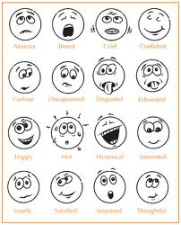

Using the symbols below, please identify the areas of concern on the chart below:

/// (sharp pain) xxx (burning , radiating pain) ~~~~ (numbness) 000 (dull ache)

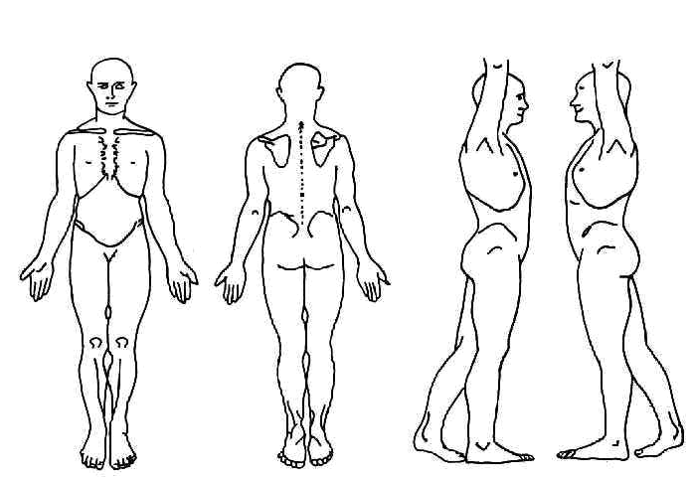

Health History
Please indicate any Present (P), Past (X), or Reoccurring (C) conditions:

____ ADD/ADHD ____Metal implants / artificial joints
____ Allergies ____ Mononucleosis
____ Alzheimer’s disease ____ Multiple Sclerosis
____ Anxiety disorder what stage? __________________
____ Arthritis ____ Muscular Dystrophy
____ Athletes foot ____ Numbness/ Tingling
____ Asthma ____ Osteoporosis/Osteopenia
____ Blood Clot/ Deep Vein Thrombosis/ ____Osteoarthritis
Phlebitis/ Embolism ____ Pain
____ Broken or fractured bones ____ Rheumatoid Arthritis ____ Bursitis -Location: ____________________
____ Cancer --Muscular or Joint: _____________
--Location: ___________________ -- Chronic? Y/N
--Treatment: __________________ ____ Paralysis
-- In Remission? Y/N ____ Parkinson’s disease
____ Carpal Tunnel Syndrome ____ Pregnancy
____ Cerebral Palsy ____ Psoriasis
____ Chronic Fatigue Syndrome ____ Rash
____ Contagious condition ____ Sciatica
____ Crohn’s disease ____ Scoliosis
____ Depression ____ Seizure
____ Diabetes ____ Sleeping problems
____ Type I ____ Type II ____ Spasms/ Cramping
____ Diverticulitis ____ Strain/ Sprain
____ Eczema ____ Stroke
____ Epilepsy ____ Tendonitis
____ Epstein Barr ____ Thyroid issues
____ Fertility Concerns ____ TMJ/ Jaw Pain
____ Fibromyalgia ____ Tumor
____ General Fatigue --Location: ____________________
____ Gout --Malignant or Benign? ___________
____ Headaches ____ Varicose Veins
--Type: __________ Frequency: ___________ ____ Vertigo, dizziness or loss of balance
____ Hearing Impairment ____Other: _____________________
____ Heart Condition
____ Herpes/ Shingles
____ High/ Low Blood Pressure
____ High/ Low Cholesterol
____ HIV/AIDS
____ Lupus
____ Lymph edema

AUM hOMe Shala Professional Disclosure Form and General Release
We are delighted to have you as a Yoga student. The following information will help you get the most out of your Yoga classes and clarify the role of a Yoga teacher. Please read and sign below.
- I am a Yoga Teacher at AUM hOMe Shala and have completed a thorough professional training in Yoga instruction. I have a Yoga Certification and am registered with the Yoga Alliance. Yoga is much more than physical exercise; it is a transformational practice that integrates body, mind and spirit. Yoga is a way of encountering and releasing physical, mental, and emotional tensions to arrive at deeper levels of relaxation and awareness.
- All exercise programs involve a risk of injury. By choosing to participate in my Yoga classes, or any other classes at AUM hOMe Shala, you voluntarily assume a certain risk of injury. The following guidelines will help you reduce your risk of injury:
- Listen to and follow Yoga Teacher’s instructions carefully.
- Breathe smoothly and continuously as you move and stretch.
- Do not hold your breath or strain to attain any position.
- Work gently, respecting your body’s abilities and limits.
- Don’t perform postures or movements that are painful.
- Ask if you are unsure how to perform a certain movement.
- Menstruating women should not practice inverted postures.
- Pregnant women must consult their health care provider before enrolling in class.

- It is always advisable to consult your physician before embarking on any exercise program. Please complete the Student Health Questionnaire Form and inform the teacher of any health conditions that could be affected by your practice of Yoga. If you are unsure about a condition, please speak to your teacher.
- Awareness is fundamental to the practice of Yoga. It is your responsibility as a student to monitor each activity and determine whether it is appropriate for you to participate. Though I am your teacher, you remain primarily responsible for your safety and well-being.

The undersigned assumes all risk of damage or injury that may occur as a student in AUM Home Shala Yoga classes, both while attending classes and following instruction at home. In consideration of being accepted as a Yoga student the undersigned releases and discharges Melinda Atkins, AUM hOMe Shala from any and all claims, demands, actions of any nature, whether present or future, anticipated or unanticipated, known or unknown, that result from the undersigned’s participation in Yoga classes or practice of Yoga outside of class.
I have read, understand, and agree to the content of the Professional Disclosure Form and General Release.
Student’s Name (please print) ______________________________________
Student’s Name (please sign) _______________________________________
Date _____________________
Student Contact # ______________________________________
E-mail Address ________________________________________
Emergency Contact Name & Phone # _________________________________________

Release and Consent to Video or Photograph
For use to promote AUM Home Shala Yoga Programs
Subject’s Name (please print):___________________________________________________
Address: ____________________________________________________________________
Phone Numbers: (H) ________________________ (Cell)___________________________

AUM hOMe Shala established its Clinical Yoga Therapy Program in 2011 to promote the use of Yoga Therapy as an integrative, alternative, and complementary form of health care. I understand that AUM hOMe Shala routinely promotes the educational, heath, and spiritual benefits of Yoga Therapy in rehabilitation. I also understand that AUM hOMe Shala creates teacher manuals and videos of technique to share with others.
I hereby consent to being the subject of photographs and videos taken for the above stated purposes and promoting Shala Yoga programs and hereby release AUM hOMe Shala from any and all claims for damages for libel, slander, invasion of privacy, or any other claim based upon the use of my image and likeness as stated above.
Signature __________________________________________
Print Name _________________________________________
Date ____________________________________

