
Clinical Yoga Therapy
Confidential Health Background
AUM Home Shala Yoga Therapy

Personal Information
Name: ___________________________________ Birthday: _____________
Daytime Phone: (_____) _________________ Evening Phone: (_____) __________________
Email Address: ______________________________________________

Occupation: _________________________
Address: __________________________ City: _____________ State: _____ Zip: ___________
Emergency Contact: ____________________________ Phone: (_____) __________________

The following confidential information will be used to plan safe and effective yoga therapy sessions. Please answer the questions to the best of your knowledge.

Reason for your visit

What is your primary issue? _____________________________________________________
How often do you experience your symptoms?
Constantly (76-100% of the time) Frequently (50-75%) Occasionally (26-50%) Intermittently (up to 25%)
When did you first notice it? _______________ Do you know what brought it on? _________
What activities provide relief? ____________________________________________________
What makes it worse? __________________________________________________________
How are your symptoms changing with time? (circle one)
Getting Worse Staying the same Getting better
Have you tried any other therapies or treatments? (Y/N)
If yes, please describe: ______________________________________________________
Describe your sleep recently: ____________________________________________________________________________

What do you hope to accomplish? ________________________________________________
_____________________________________________________________________________
___ Body Awareness
___ Muscle Strengthening ___ Muscle Stretching and Flexibility
___ Improve Other Body Systems: ___ Stabilization of Joints
___ Diet and Lifestyle ___ Pain Reduction
___ Digestion and Elimination ___ Overall Posture Improvement
___ Specific Yoga Postures or Practices ___ Improve Breathing
___ Improve Energy Level ___ Improve Sleep
___ Breath Awareness ___ Overall Stress Reduction
___ Less Trouble Handling Emotions ___ Less Reactive/Upsetting
___ Less Anxiety or Depression ___ More Satisfying Personal Relationships
___ Finding Greater Fulfillment at Work ___ Greater Sense of Self-esteem
___ Other goals:_______________________________________________________________
How much time per day can you devote to doing yoga or healing work? ________________________________________

Health History

Are you currently under a physician’s care for an acute or chronic issue? (Y/N)
If yes, please explain __________________________________________________________
Health Care Provider: _____________________Date of last Physical Exam: _________

What do you do for relaxation/exercise? ___________________________________________
_____________________________________________________________________________
Do you exercise regularly and/or participate in any sport? (Y/N)
If yes, which sport? _______________________________________________
Have you recently suffered an injury? (Y/N)
If yes, please explain _____________________________________________________________

Are you uncomfortable with any of the following areas:
Gluteal Region (Y/N) Pectoral Region (Y/N) Face/Scalp (Y/N) Feet (Y/N)

Please list any medications (vitamins, herbs or pharmaceutical) you are currently taking or at regular intervals? __________________________________________________________________________________________________________________________________________________________

Please list any injuries/accidents/illnesses or surgeries still affecting you and how you have been caring for them: __________________________________________________________________________________________________________________________________________________________

Do you experience stress in your work, family or other aspects of your life?
(Circle the one that best describes)



And how you believe it affects your health:
Muscle tension Anxiety Insomnia Irritability Digestive Disturbances
Other: _______________________________________

Circle the face or faces that best describes how you are feeling 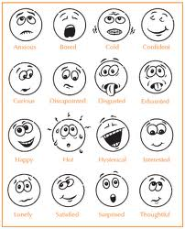

Using the symbols below, please identify the areas of concern on the chart below:

/// (sharp pain) xxx (burning , radiating pain) ~~~~ (numbness) 000 (dull ache)

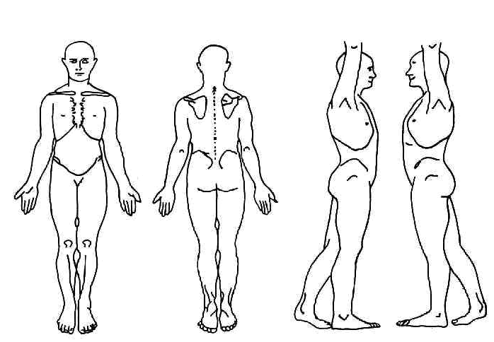

Health History
Please indicate any Present (P), Past (X), or Reoccurring (C) conditions:

____ ADD/ADHD ____Metal implants / artificial joints
____ Allergies ____ Mononucleosis
____ Alzheimer’s disease ____ Multiple Sclerosis
____ Anxiety disorder what stage? __________________
____ Arthritis ____ Muscular Dystrophy
____ Athletes foot ____ Numbness/ Tingling
____ Asthma ____ Osteoporosis/Osteopenia
____ Blood Clot/ Deep Vein Thrombosis/ ____Osteoarthritis
Phlebitis/ Embolism ____ Pain
____ Broken or fractured bones ____ Rheumatoid Arthritis ____ Bursitis -Location: ____________________
____ Cancer --Muscular or Joint: _____________
--Location: ___________________ -- Chronic? Y/N
--Treatment: __________________ ____ Paralysis
-- In Remission? Y/N ____ Parkinson’s disease
____ Carpal Tunnel Syndrome ____ Pregnancy
____ Cerebral Palsy ____ Psoriasis
____ Chronic Fatigue Syndrome ____ Rash
____ Contagious condition ____ Sciatica
____ Crohn’s disease ____ Scoliosis
____ Depression ____ Seizure
____ Diabetes ____ Sleeping problems
____ Type I ____ Type II ____ Spasms/ Cramping
____ Diverticulitis ____ Strain/ Sprain
____ Eczema ____ Stroke
____ Epilepsy ____ Tendonitis
____ Epstein Barr ____ Thyroid issues
____ Fertility Concerns ____ TMJ/ Jaw Pain
____ Fibromyalgia ____ Tumor
____ General Fatigue --Location: ____________________
____ Gout --Malignant or Benign? ___________
____ Headaches ____ Varicose Veins
--Type: __________ Frequency: ___________ ____ Vertigo, dizziness, or loss of balance
____ Hearing Impairment ____Other: _____________________
____ Heart Condition
____ Herpes/ Shingles
____ High/ Low Blood Pressure
____ High/ Low Cholesterol
____ HIV/AIDS
____ Lupus
____ Lymph edema
ASSUMPTION OF RISK/RELEASE OF LIABILITY AND INDEMNITY AGREEMENT
Assumption of Risk: I recognize the possibility of potential injury that may result from participating in Yoga classes or any other classes at Aum Home Shala (“Shala”). Being fully aware of this risk, I voluntarily choose to participate in Shala programs and accept all risks associated with that participation. In consideration of being accepted as a Yoga student, I on my own behalf, and on behalf of my heirs, administrators, executors and successors, hereby forever release and covenant not to the Shala, its officers, directors, shareholders, employees, volunteers and all others associated the Shala including Melinda Atkins, from all liability for any and all damages and injuries I may suffer while under the instruction, supervisions or control the Shala. I hereby fully agree to individually provide for all present and possible future medical expenses which I may incur as a result of any injury sustained while participating at or for the Shala.
I have read and understand this acknowledgment of policies, risk and waiver of liability and I voluntarily affix my name in agreement.

______________________________ _______________________
Student’s Name (please print) Date

________________________________________
Student or Caregiver Signature

Indemnification and Hold Harmless: I also agree to INDEMNIFY DEFEND Aum Home Shala, (“Shala”) its officers, directors, shareholders, employees, volunteers and all others associated with the Shala including Melinda Atkins HARMLESS from any and all claims, actions, suits, procedures, costs, expenses, damages and liabilities, including but not limited, attorney’s fees, arising from, or in any way related to my participation in Shala programs, classes and events, except for those arising out of the willful misconduct and/or gross negligence of the above named parties, as applicable.

I have read and understand this acknowledgment of policies, indemnification and hold harmless agreement and I voluntarily affix my name in agreement.

________________________ _____________
Student’s Name (please print) Date

_________________________ _____________
Student or Caregiver Signature Date

MEDIA RELEASE

Audio and Image Consent
By attending and participating in all Aum Home Shala (“Shala”) classes and events, I hereby grant my permission to the Shala and its officers, directors, shareholders, employees, volunteers and all others associated with the Shala, including Melinda Atkins, to be filmed, audiotaped, or photographed by any means, and grant full use of my likeness, voice and words without the expectation of compensation.
I hereby release the Shala and its officers, directors, shareholders, employees, volunteers and all others associated with the Shala, including Melinda Atkins, from all claims of libel, slander, invasion of privacy, or any other claim based upon the use of my image and likeness as stated above.
I have read and agree to the above.

__________________________ _________________
Student Name (please print) Date

___________________________ _________________
Student or Care Giver Signature Date

